A3
Holy Mandate
A Dungeons & Dragons Adventure Series
Chapter 3: Power Farming

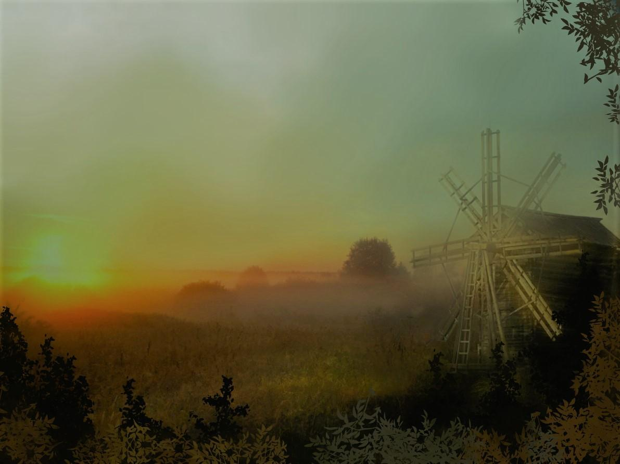

About GND Adventures
Holy Mandate is part of a new series of adventures designed to be easy to read, easy to run, and a blast to play. They focus on detailed world building that grows alongside the characters. In these pages, players will find cunning intrigue, intricate puzzles, crafty combats, and grand adventures. The Dungeon Master will find easily accessible information, full stat-blocks for any monsters, creatures, or NPC’s, and well laid out content that makes your job easier.
In the course of this adventure, some text appears in Bold. Any text, outside of a stat block, appearing in bold should be read or paraphrased to the PC’s.

Stat Blocks
Full Stat Blocks are enclosed for each creatures or NPC used in this adventure. Abbreviations are used in some places. An explanation of the stat blocks and those abbreviations is listed below.
Example:
8 Brick Skeletons (Number and type of creature appearing in the encounter)
Atk (Attack): Shortsword +4 1D6+2 Dmg (P) (Damage amount and type; (B) Bludgeoning, (P) Piercing, (S) Slashing), HP: 15, AC: 14, Speed: 30; Saves: (+0,+2,+2,-2,-1,-3) (Save values for Strength, Dexterity, Constitution, Intelligence, Wisdom, and Charisma in that order); M (Size. (S) Small, (M) Medium, (L) Large) Undead, LE (Alignment)
Vul: (Vulnerabilities) Bludgeoning, Imm: (Immunities) Poison, Exhaustion, Poisoned. Darkvision 60 ft. Perception 9. CR ¼

NPC’s
Key NPC’s are described in detail, but random and minor NPC’s have stat blocks that tell their gender, race, age, and general character traits. They appear as such:
M/HE/25/Random and Aloof.
Explanation
Gender (M(Male), F(Female))/Race (Hu(Human), HE(Half-Elf), Dw(Dwarf), E(Elf), G(Gnome), Hl(Halfling), HO(Half-Orc), DB(Dragon Born), TF(Tiefling))/Age(years old in appearance)/Character traits(How they usually interact with the world.)
Introduction
Just outside the Lonely Desert, on the edge of civilized lands stands a massive 200 ft., black cube known as The Brick. Glyphs and symbols adorn The Brick, etched into its impossibly hardened sides in an ancient forgotten language. Some say The Brick is a doorway between the living and the dead. Some say it is a gateway to another plane. Still others claim that it is the foundation for the entire world and discovering its secrets will unlock the keys to the multiverse.
Every night, as the sun falls below the horizon, the glyphs on The Brick blaze to life in a hundred different hues. The Brick can be seen for miles and is a dazzling display, that is, before it vomits forth it's horde of undead. A seemingly steady stream of zombies, skeletons, and worse exit The Brick and roam the night, venturing out only as far as it would take them to return by the time the sun makes its appearance in the morning. Even worse, at random intervals throughout the year, The Brick releases a violent, negative shock-wave that destroys anything in its path. Tress, animals, even rocks are destroyed by this wave. Those that fall, rise again as undead versions of their past self.
Into this unique landscape clerics and holy orders of all types come to The Brick to train in destroying and controlling undead. The vast majority of the undead are lowly skeletons, zombies, and other common types, but every once in a while, a truly intelligent undead will venture out and compel the undead waves to a specific task.

What secrets does The Brick hold? What treasure might be uncovered within its black sides? Gather your companions, grip your holy symbols, and bring light into true darkness as you come face to face with the mysteries of The Brick.

Γ Ν Δ

This series of adventures takes place in and around the Town of Safepoint, an area about two miles south of The Brick. It is the furthest point that a shock-wave has ever been recorded and is heavily fortified by holy orders that train in fighting off the undead. Once the PC's have gathered enough experience and power, they will find themselves entering The Brick itself in an effort to discover its lost secrets. The adventure is broken up into 12 parts and designed to start with first level characters. Each Chapter is set-up to run in one evening and should give the PC's enough experience to advance to the next level. They are designed as a fast paced, hack and slash adventure with problem and mystery elements.

Chapter Synopsis
Chapter 3 is a straight up, old school hack and slash adventure that will challenge the PC’s tactical abilities. The PC’s will investigate a farmstead south of Safepoint in hopes of discovering clues to the mysterious Cult of Withering Rebirth. Along the way cunning PC’s will use all the skills at their disposal to survive the tainted farm and its enigmatic owner.
What’s really going on.
A powerful Lich emerged one evening from The Brick several months past. Since then she has established herself as a reputable citizen and even manipulated events to get herself elected mayor. She is building a following of cult members to help undermine the town’s defenses. One of her Lieutenant’s, Theodore Banderling has been using the farm as a base of operation to experiment on poisoning the town food supply. He has also been experimenting with creating new types of undead.

Hooks
There are many reasons why the PC’s might head to this particular farmhouse. Here are a few ideas if needed.
If the PC’s are following the adventure flow, they will have discovered a clue hinting of the mysteries of The Wardstrom Estate.
The PC’s are hired to clear out the haunted estate by a potential buyer.
The PC’s have heard rumors that the estate was abandoned and locals tell of strange sounds at night.
One of the PC’s stands to inherit the estate or it has been awarded for good deeds.
One of the PC’s has a friend or relative that disappeared around this area, a victim of Theodore’s experiments.

Key NPC’s

Lady Falow Parson. Looks early 30’s or late 20’s, Human, female, strawberry blonde hair, pretty. Smiles and laughs easily. Her eyes seem older. Current elected mayor of the town. Will seem very helpful to the PC’s investigations. However, she is really known as The Falow Princess, a Lich in disguise from The Brick. She will attempt to manipulate the PC’s into causing discontent in the town. Her goal is to bring about the destruction of Safepoint and raise it’s residents as her army. Note that Lady Falow wears a ring of mind shielding and is excellent at deception. Falow will do everything in her power to hide her true form from the PC’s. On a practical note, if the PC’s find out the truth and try to take her on too early, she would be way too strong. F/Hu/28/Helpful and flirty

Theodore Banderling. Seemingly a man in his late 40’s with a frail frame and balding hair. His eyes appear sunken and his face is rarely without a scowl. One of Lady Falow’s minor Lieutenants, he specializes in zoology and botany, specifically, how to turn the natural into the supernatural. He requested the gift of undeath from Lady Falow several years ago and was remade as a wight. He long ago turned his back of society due to the death of his wife and son, and wants to see the world suffer. M/Wight/45/Angry and cunning.

Hard Doug. An awakened giant badger, Hard Doug was brought to conscious by a passing Druid who had nothing better to do. Since then he has been living in the Wardstrom Estate eating out the pantry. He does not like undead and would love it if they were all gone. He minds his own business and just wants to eat and live in peace. He knows the corn on the estate is bad, despite it looking fine. Other than that, he’s just an intelligent giant badger. Speaks Gnomish. M/Badger/30/Boring and Polite
Trevor Wardstrom. Son and heir to the Warstrom Estate, he took off several years ago after he fell out with his parents. Since then he has been adventuring and is an accomplished rogue. Attractive, young, good-hearted, and carefree he leads a simple life of adventure and pleasure. He’s a sucker for women and tries to entice them whenever possible. He is loyal to friends and will repay kindness in turn. But, will also hold a grudge and work behind the scenes to wreak vengeance on those that treat him poorly. He has no plans to settle down on the estate yet, maybe someday when he finds the right girl. M/Hu/22/Carefree and Good-hearted

Investigations
If the PC’s take the time to head back to Safepoint to do some informational gathering, reveal some of these facts as they make Investigation checks. Not all of these rumors are true; some don’t even make much sense. They exist to add flavor or foreshadow future events. Each time the PC’s are looking for clues or other guidance; have them roll Investigate Checks, DC 10. Success rewards one of the following rumors.

- The Wardstrom Estate is haunted by the ghost of the former owner, Mikas Bigsly

- Some undead that journey out at night are able to survive the next day by latching on to areas or people that are extremely evil.

- The last owners of the Wardstrom Estate went missing about six months ago.

- Many people have been complaining about the taste of the corn in town recently.

- The town vampire is branching out and making vampire spawn to serve him. Soon the town will be overrun.

- The telltale sign of a ghost is that your entire body begins to shiver. If you ever get the shivers, you are probably already dead.

- Strange lights have been seen coming from the upper windows of the Wardstrom Estate at night.

- The Jackobson farm beast has been revealed as a corrupted centaur. He strikes in the night and leaves arcane glyphs on the ground.

- Be careful when trying to turn undead on a layline of evil, it can backfire with dramatic consequences.

Act 1: The Wardstrom Estate, First Floor
The adventure starts with the PC’s on the road to the Wardstrom Estate.
The directions you got lead you down several side roads and deep into the country. Rolling hills quickly become dominant and before long the horizon is obscured by terrain that juts up and down. You come around a last bend and an iron wrought fence-gate stands in front of you. The gate stands open and words in an arch above it reads, “Wardstro state”, with empty spaces where the missing letters should be. Beyond lies acres and acres of half-grown corn and in the distance, a large manner house and silo.
The manner is laid out in a large square, with fields of corn dominating most of the land. At the center stands the farmhouse and silo. The PC’s are free to approach the farm house from any direction. As the PC’s head in, read or paraphrase the following.
As you journey deeper into the estate, the clouds seem to thicken and shadows seem to deepen. The wind picks up and the temperature drops as if you were entering an underground pantry. No birds adorn the few trees in the area, no animals nibble at the corn. Your only companions are the echoing of your steps and a few scarecrows that seem to watch as you approach.
Ensure the PC’s get the feeling they are entering a dangerous and evil place. Religious devotes of good will feel especially shaken, as if the connection to their gods are strained.
The PC’s are free to examine the corn. A Nature Check DC 14 will reveal that it appears healthy and eatable. A Nature Check DC 21 reveals that although it appears healthy, there is something unseen and rotten about it.
As the PC’s walk, give a Perception Check DC 15 reveals that the three scarecrows in the distance seem to shift and move whenever the PC’s look away.
If the PC’s move up and examine the scarecrows they will attack. (DC 16 Insight Check or the Scarecrows receive a surprise round)
If the PC’s attack with ranged weapons the Scarecrows will fall into the corn, receiving total cover and become untargetable until either they emerge from the corn to attack or the PC’s enter and get within 10 feet of them.
If the PC’s ignore the scarecrows or when they approach the manner house, read or paraphrase the following: You move ahead and come up to the large manner house. The building is three stories tall with a dozen windows, all of which appear shuttered with thick, iron bars in front of them. A heavy, wooden double door with the initials W.E. stands shut across from you.
If the scarecrows have not yet attacked: You turn and look back and notice the three scarecrows are gone. A split second later, they fly from the corn flailing their arms with an eerie moan.

3 Scarecrows
Atk: Slam +5 1D6+3 Dmg (B), HP: 24, AC: 16, Speed: 30, Fly 30; Saves: (+3,+3,+0,-2,-2,-3); M Undead, LE Resist: Bludgeoning; Vul: Fire; Imm: Poison, Exhaustion, Poisoned. Darkvision 60 ft. Perception 9. S.A. Flail: +5, 1D6+3 to all within 5ft. Recharge: 5-6, CR 1

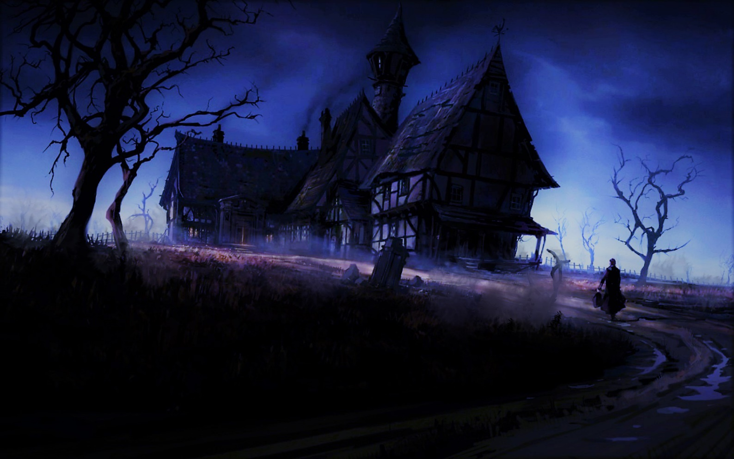

The Manner House
The manner house is made of solid brick and wood. The windows are shuttered and barred, all of them protected by Arcane Lock spells, making their Break DC 34.
The front door is not locked although a Detect Magic spell will reveal there is Abjuration magic on it.
Additionally, a dark foreboding accompanies the PC’s while they explore here. Every room it feels like they are being watched or that the walls are closing in, making rest impossible.
The inside has been laid out as logically as possible, but the DM should be familiar with the entire house as the PC’s explore.
Finally, all undead make Turn Undead Checks with advantage and receive a +2 to their Dexterity Scores within the manner. (adjusted in the stat blocks)
1) Entrance Hall
The door opens easily to reveal a large foyer. A massive glass chandelier dominates most of the 20 ft. ceiling. A door on each side wall leads out and the room itself is filled with chairs, couches, and tables of all shapes, arranged as if to entertain guests. Finally, two arching staircases flank each side of the room leading up to a second floor landing, although the last five feet of the staircase has been piled up with books, boards, and other debris creating a physical barrier. From behind the barrier you see movement, moments before crossbow bolts rain down.
2 Brick Skeleton Crossbow
Atk: Crossbow +5 1D8+2 Dmg (P), Range. 60/120 HP: 15, AC: 15, Speed: 30; Saves: (+0,+3,+2,-2,-1,-3); M Undead, LE; Vul: Bludgeoning, Imm: Poison, Exhaustion, Poisoned. Darkvision 60 ft. Perception 9. CR 1/4
The skeletons wear tattered farm cloths and fight until destroyed. Getting over the barrier requires an Athletics Check DC 15. Two additional Skeletons await with spears if the PC’s reach the archers. Firing behind cover gives the Archers
8 Brick Skeletons
Atk: Spear +5 1D6+3 Dmg (P), HP: 15, AC: 15, Speed: 30; Saves: (+0,+3,+2,-2,-1,-3); M Undead, LE Vul: Bludgeoning, Imm: Poison, Exhaustion, Poisoned. Darkvision 60 ft. Perception 9. CR ¼
If the PC’s investigate the room, an Investigate Check DC 17 reveals a box under a loose floorboard. The box has 17 gp., a steel key with the initials CWR carved into it, and a jeweled dagger worth 25 gp. in it.
Two doors lead off to either side at the top of the landing.
2) Library
The library door is locked, requiring the master key from Theodore or a Sleight of Hands Check DC 20 with Lock Picks. Alternatively, it can be broken open with a DC 23 Strength Check or hacked to pieces by doing 50 points of damage to it with Bludgeoning or Slashing weapons.
This room was once a fairly nice library. Bookcases line the walls and thick red carpet covers the floor. Three comfortable looking chairs straddle a thick, wooden table in the middle of the room. All that remains of the books are a few tomes here and there. Sitting in each chair is the bloaded body of a human, each with numerous stitches on their sides. As you enter, they raise their heads and moan before heading toward you.
Enhanced Brick Zombies
Atk: Slam +3 1D6+1 (B), HP: 25, AC 10, Speed: 20; Saves(+1,-1,+3,-4,-2,-3); M Undead, NE
Imm: Poison, Poisoned. Darkvision 60ft. Perception 8. CR ¼. Undead Fortitude: If reduced to 0 HP, Con save DC 5+ Dmg taken. On save, HP drops to 1 instead. Radiant & Crit Dmg. Negates. Enhanced with Bolster Undead.
Spear Zombie: Spear +4 1D6+3
Armor Zombie: +1 to AC
Acidic Zombie: Melee attackers take 1 acid dmg per attack.
Explosion Zombie: On death, kernals of corn explode from the body doing 2D6 Bludgeoning damage to all within 10 ft.
Each zombie is unique and should be described as such; I.E. the spear zombie uses a spear, the acidic zobies skin is slimy, the armored zombie appears a bit sturdier.
After the fight, PC’s might will have noticed the uniqueness of these zombies. A Medicine Check DC 16 tells the PC’s that each body has something sown into it. (except for the body that exploded). If the PC’s take the time, they find a spear head in one, a snake body in another, and a scrap of chainmail in another.
All the books here are on mundane activities such as sewing, building construction, cooking, and such. Cunning PC’s will notice that the bookcases cut the room off about 3 feet short on either side. (Perception 21). An Investigation Check DC 18 reveals a floor button hidden under the carpet in the corner. Pushing it opens the latch on one of the bookcases, causing it to swing open.
Behind the bookcase is an L shaped room covered in dust. Survival Check DC 14 indicates no one has been here in years. The room holds 15 framed paintings, stolen and stashed here by the son of the previous owner, Trevor Wardstrom. Each has a value of 50 x 1D6 gp. to the right collector, though they are quite bulky and hard to carry without damaging or ruining them. Folding or trying to take the paintings on the bulk of the adventure will damage them, reducing their value in half. A Perception Check DC 19 reveals two initials carved into the wall, T.W.
3) Kitchen
This door is locked, requiring the master key from Theodore or a Sleight of Hands Check DC 20 with Lock Picks. However, a barrier has been placed on the other side to reinforce the door. Once unlocked it requires a DC 25 Athletics Check to push open. Alternatively, it can be broken open with a DC 23 Strength Check or hacked to pieces by doing 50 points of damage to it with Bludgeoning or Slashing weapons.
This room is obviously a kitchen of some means. Several cabinets and washing basins dot the room as well as well-kept fire pits. A door sits ajar to what looks like a large, well-stocked pantry. Out of that pantry a wispy apparition appears. It is completely silent, but seems to be mouthing “Get Out” as it approaches.
The “ghost” is just a Silent Image conjured by Hard Doug, the giant Badger. The image will attempt to chase the PC’s from the room, but if the PC’s do not run, the apparition will disappear through the south wall. If the PC’s chase it outside, there is no sign of it. If the PC’s explore the pantry, they will find Hard Doug, who is careful, but polite. He will tell them his story and tell them about the man with the caved head (Theodore), who seems to be experimenting on the corn. He also tells them Theodore can create undead and has a collection upstairs.
Hard Doug can’t help them much, but he will share the pantry food with the party if they want and would be ever grateful if they cleared out the undead. He’ll try to warn of anyone approaching from outside by making a crow sound.

Act 2: The Wardstrom Estate, Second Floor
4) Living Quarters
This door is locked, requiring the master key from Theodore or a Sleight of Hands Check DC 20 with Lock Picks. Alternatively, it can be broken open with a DC 23 Strength Check or hacked to pieces by doing 50 points of damage to it with Bludgeoning or Slashing weapons.
Inside a large, plush living quarters is dominated in the center by a grand bed with canopy. Thick pillows and blankets lay in a mess on it. Along the walls sit a wardrobe, bathtub, and tall mirror. The entire room has the look of recent use.
Theodore uses this as his personal room for sleep and hygiene. He keeps most his mundane cloths and traveling gear here as well. In the wardrobe is a bandoleer of daggers, snug, black leather armor, and a coin purse with 26 gp. in it. Under the bed is his backpack filled with typical adventuring gear. I.E. rope, rations, water skins, etc.
In the far corner, there is a false ceiling. It can be spotted with a Perception Check DC 18 or an Investigation Check DC 16. Once spotted the trigger to release the ceiling and reveal the ladder up becomes apparent.
DEVELOPMENT:
As the PC’s explore Trevor Wardsrom will return for his cache. If the PC’s have made friends with Hard Doug he’ll make his crow sound. If not, give the PC’s a Perception Check DC 22 to hear him enter and move up the stairs. If they do not hear him he will sneak up and place a dagger to one of their throats, demanding to know who they are.
Trevor will be confused by the PC’s presence, indeed by the state of the estate. He’s is rational though and will hear the PC’s out. If he finds the skeletons with the farm cloths on, he’ll recognize them as his parents. If the PC’s are open to it, he’ll join them as they explore the rest of the estate. He knows all the secrets of the place and will openly share them. However, if the PC’s are suspicious, he’ll take is trove of paintings, or at least ask for half, and be on his way. If the PC’s have found the paintings he’ll request them before he goes as he worked hard in his youth to acquire them.
5) Experiment Room
This door is locked, requiring the master key from Theodore or a Sleight of Hands Check DC 20 with Lock Picks. Alternatively, it can be broken open with a DC 23 Strength Check or hacked to pieces by doing 50 points of damage to it with Bludgeoning or Slashing weapons.

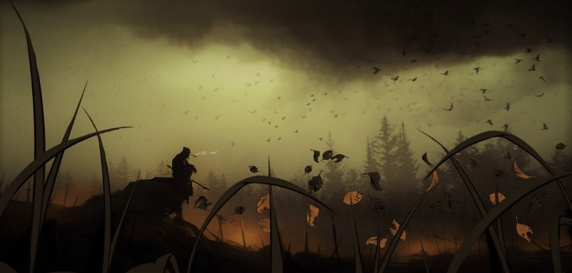

The door opens to the pungent smell of herbs and formaldehyde. Around the room are six tables, each holding a cadaver in various states of assemblage, some missing arms, others legs, one a head. A large center table holds tubes, beakers, heating elements, herbs, and other alchemical items. Corn husks lie strewn around the room as well.
All the bodies here are just that, bodies. A Medicine Check DC 14 indicates that the bodies are in a very slow state of decay. Each body has a stitched up incision in their chest. Opening them reveals a piece of corn stuck into each body, seemingly petrified.
The alchemical reagents are worth 65gp in town. Hidden under the main table, taped to the underside is a scroll with 4 spells, Lesser Restoration, Cure Wounds, Detect Magic, Invisible Object. (See Appendix 1) Investigate DC 12 to find.
Act 3: The Wardstrom Estate, Third Floor
6) Sitting Room
You climb the ladder up into small sitting room. Three chairs rest in the area dominated by a large painting of a mountain landscape. A serving cart with silver dishes and pitcher stands between the chairs. Two doors lead off to the east.
The dishes and pitcher are all silver and worth 50 gp together. Inside the pitcher is an odd concoction that smells like sweet tea. A Nature Check DC 20 reveals it is a poison. Anyone drinking it must succeed on a DC 16 Constitution Check of take 1D6 points of Constitution Damage. This damage heals after a long rest.
7) and 8) Storage
These doors are locked and Arcane Locked, requiring the master key from Theodore or a Sleight of Hands Check DC 30 with Lock Picks. Alternatively, it can be broken open with a DC 33 Strength Check or hacked to pieces by doing 70 points of damage to it with Bludgeoning or Slashing weapons.
These rooms are animated corpses that are awaiting implanting. If either door is opened, they will fight until destroyed.
7) 4 Brick and 5 Brick Skeletons
8) 8 Brick Skeletons and 2 Brick Zombies
Brick Zombies
Atk: Slam +3 1D6+1 (B), HP: 25, AC 10, Speed: 20; Saves(+1,-1,+3,-4,-2,-3); M Undead, NE
Imm: Poison, Poisoned. Darkvision 60ft. Perception 8. CR ¼. Undead Fortitude: If reduced to 0 HP, Con save DC 5+ Dmg taken. On save, HP drops to 1 instead. Radiant & Crit Dmg. negates
Brick Skeletons
Atk: Shortsword +5 1D6+2 Dmg (P), HP: 15, AC: 15, Speed: 30; Saves: (+0,+3,+2,-2,-1,-3); M Undead, LE
Vul: Bludgeoning, Imm: Poison, Exhaustion, Poisoned. Darkvision 60 ft. Perception 9. CR 1/4
9) Hallway
The door opens to reveal a long, 30 ft. hallway to a door at the other end.
As soon as the first PC is halfway down the corridor, read or paraphrase the following, adjusting if the PC’s have cleared out the first storeroom.
The door in front of you swings open suddenly to reveal a man in leather armor and dark, purple robes. The side of his skull is partially caved in and a sadistic smile rests on his lips. “Oh look. The fools are bring bodies to me now. Thank you. Soon you’ll be part of my growing horde. Kill them!” A loud click from behind you indicates a door just opened. You turn to see undead coming from the back just as more pour out of the door in the front.
The hallway is a difficult, mad fight with Theodore commanding his troops and lobbing spells at the PC’s. If the PC’s have not cleared out the first storage room, it might prove deadly. If the PC’s are having a hard go and have not let Trevor Warstrom in their group, he could make a surprise appearance here, helping the PC’s fight their way back.
4 Brick Zombies and 5 Brick Skeletons (from storage room 7)
8 Brick Skeletons and 2 Brick Zombies (from storage room 8)
Theodore Banderling
Atk: +6 Life Drain 1D6+2 necrotic Dmg (Con Save DC 13 or HP reduced by Dmg taken), HP: 72, AC: 16, Speed: 30; Saves: (+2,+5,+3,+7,+2,+2); M Undead, LE; Imm: (Immunities) Poison, Exhaustion, Poisoned. Darkvision 60 ft. Perception 9. CR 5
Spells: Cantrips: Poison Spray, Mage Hand, Chill Touch, Ray of Frost
1st: (4), Identify, Grease*, Magic Missile, Thunderwave*, Disguise Sel*f, Charm Person*, Mage Armor
2nd (3) Acid Arrow*, Ray of Enfeeblement*, Scorching Ray*, Gentle Repose, Misty Step, Arcane Lock, Invisible Object
3rd (2) Animate Dead, Fear*, Vampiric Touch*, Bolster Undead
* Currently memorized
Strategy: Theodore is smart and cunning. He will not risk harm while his minions are alive, but fights to the death if cornered. He knows Lady Falow will bring him back with her dark magic and believes he has nothing to fear in death. After 4 rounds of fighting, he’ll retreat out the window and across his invisible bridge to the silo. There he’ll prepare in case any of the PC’s survive. He’ll concentrate his spells on hurting the strongest looking PC, or on finishing off one that is especially hurt.

10) Study
You enter the final room in the estate which appears to be a well-kept study. A large desk with books and notes takes up most of the space and a window, the first one you’ve seen unbarred covers part of the east wall.
Theodore’s study is a practical affair. One large desk topped with an unsent letter, 3 books (On Crops And Growing, Death And Her Agency, A Guide To Better Undead ), a black key with a purple band around it, and a metal glyph shaped like a reverse “C” with a diagonal line through the center. In a large drawer in his desk are 15 pieces of obsidian, each worth 100 gp. and a bag of dust. Nature Check DC 16 indicates it is actually diamond dust worth 500 gp. The books are simple educational tomes, but anyone taking the time to read the last (which takes 2 weeks of study) receives a permanent +1 Bonus to Religion Checks to identify undead creatures. The key is a master key to the estate and opens any and all doors that have been Arcane Locked by Theodore.
The glyph hums with energy and glows a brilliant green each evening when the sun goes down. Canny PC’s will recognize it as one of the glyphs from The Brick.
Theodore’s Unsent Letter
My Lady,
My plan to create an undead plague using the corn has so far been unsuccessful. I’ve managed to hide the rot, but the disease has not taken hold. I’ve grown frustrated and instead have been working on bolstering our current undead. I’ve had promising results by using the power of The Brick with my own spells. I will brief you personally when next we meet. May your godly intellect and cunning continue to guide The Cult of Withering Rebirth until they day comes we can reveal ourselves to these pathetic souls. I remain, your eternal servant.
Theodore Banderling
The window although shuttered opens with a forceful push. Opening it leads to the invisible rope bridge and the silo, 40 ft. away. However, PC’s would only see what looks to be a fall to the ground. A Perception Check DC 21 reveals that there is something blocking sight to the ground along a 2 ft. path towards the silo. The rope bridge is made of numerous pieces of rope with Invisible Object spells placed upon them and tied together. Crossing the rope bridge requires 2 Acrobatics Check DC 14. Failure by 5 or more cause the PC to fall to the ground, taking 2d10 Dmg., although an Acrobatics Check DC 16 reduces this damage in half.
Silo)
The silo is nearly thirty feet high and made of stone and mortar. As you approach the single door, you receive a horrendous smell of decay and death. The door is not locked and is easily opened.
Near the top of the Silo, facing the manner is a small, hidden door. It is hard to see from the ground Perception DC 30, but easier from nearby, Perception DC 20. Anyone climbing or flying up the silo would have a chance to notice the door.
Once opened:
Inside is a harvest of death. Bodies; human, dwarf, elf, orc, goblin, all in various states of decay lay in piles around the room. Nothing moves and luckily what little light the spills in from the doorway obscures the details of this gruesome scene.
This is where Theodore leaves the bodies of his victims until he gets around to working on them. Sensing easy food, a pair of Brick Ghouls have moved into the silo and use it as a layer. Theodore doesn’t care what state the bodies he works on are in, so has left the ghouls alone for now.
Brick Ghouls
Atk: Bite +3 2D6+2 (P) and Claws +4 2D4+2 (S) (Con Save DC 10 or Paralyzed 1 minute, repeat Save end of each round), HP: 24, AC 13, Speed: 30; Saves(+1,+2,+1,-2,+0,-2); M Undead, CE
Imm: Poison, Poisoned, Charm, Exhaustion. Darkvision 60ft. Perception 10. CR 1.
Silo Top Room)
This hidden room is accessible only through the secret door near the Silo top. It is Arcane Locked with a Sleight of Hands DC of 30 to open with lock picks. Alternatively, it can be broken open with a DC 33 Strength Check or hacked to pieces by doing 70 points of damage to it with Bludgeoning or Slashing weapons. Theodore’s key will also open the door.
If Theodore is here, he will do everything in his power to fight off the PC’s at the entrance, using his two Sword Zombies as door guards. If he is not here, the Sword Zombies fight anyone who enters.
Sword Zombies (2)
Atk: Longsword +4 1D8+4 (B), HP: 28, AC 10, Speed: 30; Saves (+2,-0,+4,-3,-1,-2); M Undead, NE
Imm: Poison, Poisoned. Darkvision 60ft. Perception 8. CR ¼. Undead Fortitude: If reduced to 0 HP, Con save DC 5+ Dmg taken. On save, HP drops to 1 instead. Radiant & Crit Dmg. Negates. Bolstered via Bolster Undead: Weapon Prowess
Inside is a small cache of wealth seemingly taken from all walks of life. There are several random pieces of jewelry, a few paintings and statues, random sacks of gold and silver, and a great deal of mundane items such as rope, torches, rations, etc. All told, the loot in here could be sold for 2,500 gp. Additionally, one bag is a Bag of Holding and another contains a Cloak of Protection he hasn’t yet identified. Theodore will have his spell book on him at all times containing the spells in his description.

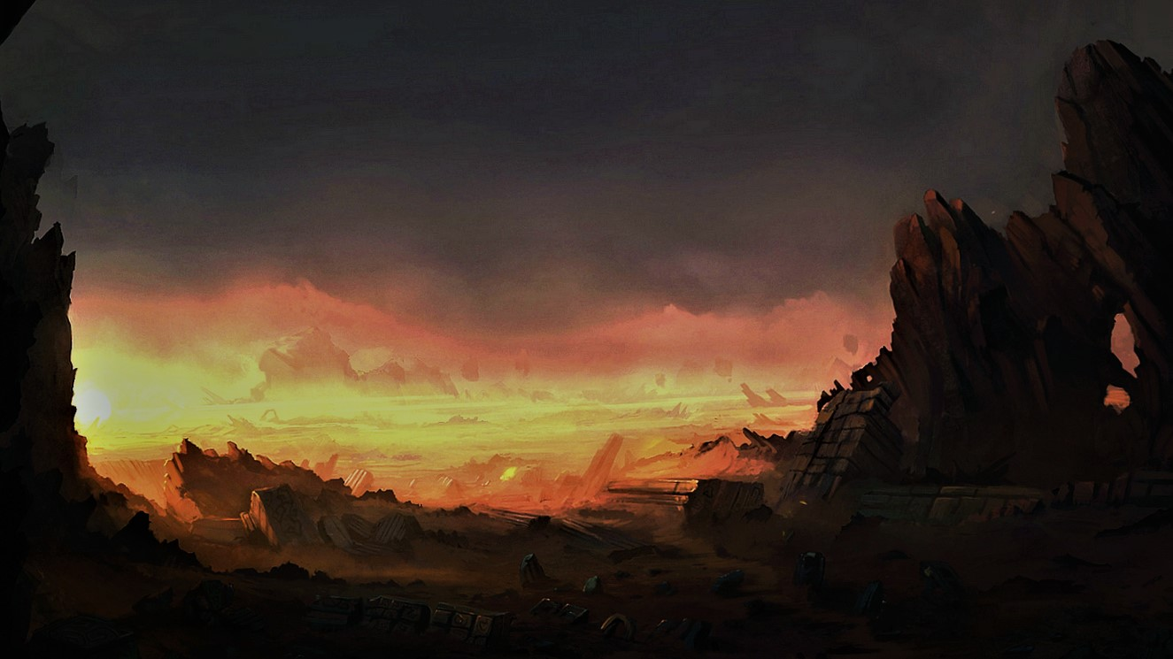

Wardstrom Estate
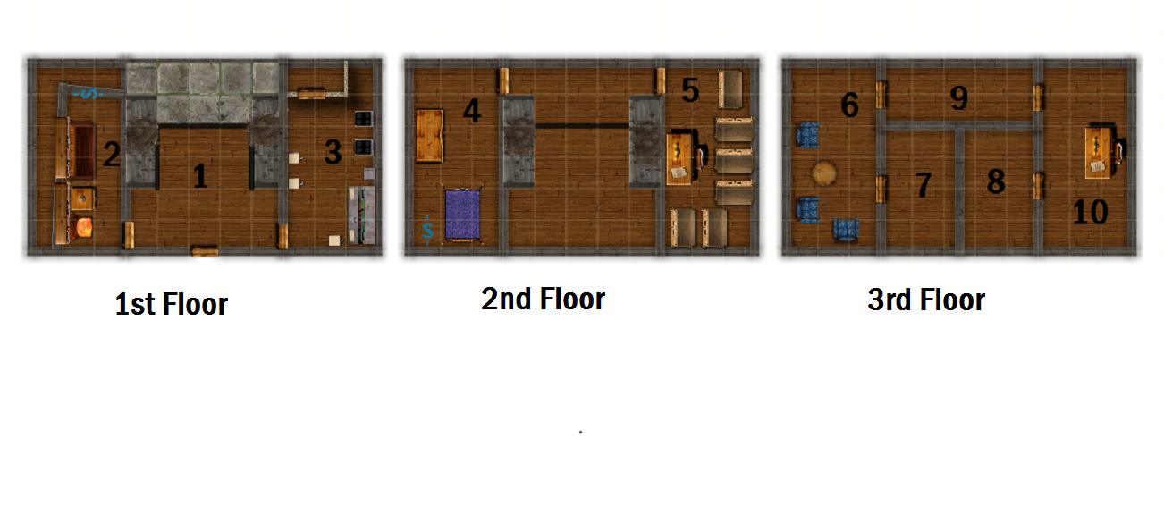

Rough Dimensions
1: Entrance Hall, 25ft. x 30ft.
2: Library, 15ft. x 30ft.
3: Kitchen, 15ft x 30ft.
4: Living Quarters, 15ft x 30ft.
5: Experiment Room, 15ft. x 30ft.
6: Sitting Room, 15ft. x 30 ft.
7: Storeroom, 15ft. x 20ft.
8: Storeroom, 15ft. x 20ft.
9: Hallway, 25ft. x 10 ft.
10: Study, 15ft. x 30 ft.
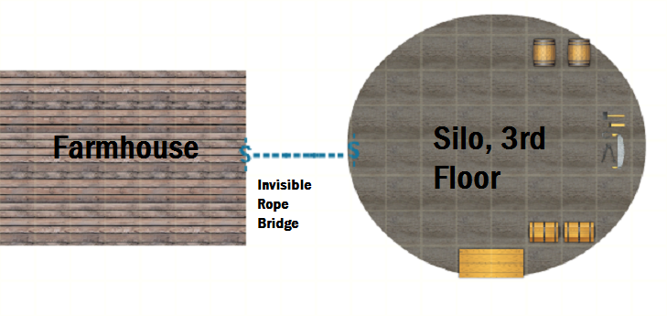

Denouement
The PC’s now have a few more clues to go on. They have one of the glyphs from The Brick and can use it to gather even more information in the future. They have a letter indicating that the threat of corrupted corn seems over, and they know that there is indeed a greater conspiracy with The Cult of Withering Rebirth.
If the PC’s have befriended Hard Doug he’ll be very grateful and give the PC’s a few “rocks” he found. (6 amethysts each worth 250 gp.). If Trevor was treated well he’ll befriend the PC’s and will be a good contact in the future if the PC’s need any help.

This ends Chapter 3 of Holy Mandate. Award the PC’s enough experience to advance to level 4. Chapter 4 will see the PC’s unraveling mysteries of gaining entrance to The Brick and trying to foil yet another plot from The Cult of Withering Rebirth.
Did something unexpected or amazing happen? Was there an especially epic or noteworthy encounter? Drop us a line at geeksnextdoorftw@gmail.com. We would love to hear from you. We will talk about it on our Geeks Next Door podcast and maybe even use your encounter as an NPC to liven up the world.

New Creatures
Scarecrow
Medium Undead, lawful-evil
Armor Class: 16
Hit Points 24 (4d10 +0)
Speed: 30 ft., Fly 30 ft.
Str. 16 (+3), Dex 16 (+3), Con 16 (+0), Int 6 (-2), Wis 7 (-2), Cha 4 (-3)
Senses: darkvision 60 ft., passive Perception 9
Languages --
Challenge 1 (200 XP)
Actions
Slam. Melee Weapon Attack: +5 to hit, reach 5 ft., one target. Hit 9 (1d6+3 ) bludgeoning damage.
Flail: As an action, the Scarecrow can whip it’s arms around in a wide area. Any non-scarecrow within 5 ft. of the Scarecrow takes 1D6+3 Dmg. This ability recharges on a roll of 5-6 on a D6.

Description
A scarecrow is an undead abomination brought to life through dark, necromantic magic. They appear as typical scarecrows, but move with speed and agility when they attack. They are experts at hiding in fields until they wish to be discovered and receive full cover in any field over shoulder height. Mindless, Scarecrows have no fear of destruction and attack when promoted regardless of the environment. A scarecrow can be given simple orders by its creator such as; “Guard an area”.

Full NPC stat Blocks
.
Theodore Banderling, Wizard Lvl 5
Atk: Life Drain +6 1D6+2 (Necrotic), HP: 72, AC: 16, Speed: 30, Saves: (+2,+5,+3,+7,+2,+2); M Undead, LE
Str: 15, Dex: 16, Con: 16, Int: 18, Wis: 14, Cha: 15
Skills: Arcana +7, Medicine +5, Religion +5, Perception +5.
Spellcasting: Theodore is a 5th level spellcaster. His spell book contains the following spells.
Cantrips (at will): Poison Spray, Mage Hand, Chill Touch, Ray of Frost
1st level (4 slots): Identify, Grease*, Magic Missile, Thuderwave*, Disguise Self*, Charm Person*, Mage Armor
2nd level (3 slots): Acid Arrow*, Ray of Enfeeblement*, Scorching Ray*, Gentle Repose, Misty Step, Arcane Lock, Invisible Object
3rd level (2 slots): Animate Dead, Fear*, Vampiric Touch*, Bolster Undead
Abilities: Life drain. Melee weapon attack: +6 to hit, reach 5 ft., one creature. Hit: (1d6 + 2) necrotic damage. The target must succeed on a DC 13 Constitution saving throw or its hit point maximum is reduced by an amount equal to the damage taken. This reduction lasts until the target finishes a long rest. The target dies if this effect reduces its hit point maximum to 0. A humanoid slain by this attack rises 24 hours later as a zombie under Theodore’s control, unless the humanoid is restored to life or its body is destroyed.
Equipment: Black Leather Armor, Spellbook,
Description: Appears Male human. Thinning black hair atop a face that has had the left side crushed and caved in. His eyes turn red when he is angered. Loves to study undead and research new spells. Loyal to The Cult of Withering Rebirth and its leader as she is the one who gave him life. Cruel and Calculating.

Trevor Wardstrom, Rogue Lvl 3
Atk (1): Shortsword +6 1D6+4 (P), HP: ##, AC: ##, Speed: 30, Saves:(+1,+6,+2,+1,+4,+3); M Humanoid, NG
Str: 13, Dex: 18, Con: 14, Int: 12, Wis: 15, Cha: 17
Skills: Acrobatics: +7, Athletics +3, Perception +5, Sleight of Hand +7, Insight +5, Persuasion +5, Stealth +7
Abilities: Cunning Action: Bonus action on each of your turns to take the Dash, Disengage, or Hide action. Fast Hands: Bonus action to make a Sleight of Hand check, use your thieves' tools to disarm a trap or open a lock, or take the Use an Object action. Second-Story Work: Climbs at normal speed and running jumps increase by 4 feet.
Equipment: Studded Leather Amor, Crossbow, (20) Bolts, Shortsword, Dagger (2), Backpack, Adventures Kit, 255 gp.
Description: Early 20’s, Male Human. Neatly kept brown hair and goatee. Expensive looking cloths under dirty traveling attire and a purple cape. Son of the former Wardstrom Estate owners. Left after a falling out and has come back to claim the treasure he left. Saddened and angered over the state of the farm. Is very sure of himself and his abilities, too much so. Polite, loves the lifestyle of the rich. M/Hu/21/Good-Natured and Cocky.

Hard Doug, Awakened Badger
Atk: Bite +3 1D6+1 (P) and Claws +3 2D4+1 (S), HP: 13, AC: 10, Speed: 30, Burrow 10 ft. Saves:(+1,+0,+2,+0,+1,-3); M Beast, NG
Str: 13, Dex: 10, Con: 15, Int: 10, Wis: 12, Cha: 5
Skills: Passive Perception 11
Abilities: Keen Smell: Advantage on Perception checks that rely on smell.; Cantrip: Can cast Silent Image 1/day.
Equipment: None
Description: Hard Doug was your typical giant badger until a passing Gnome Druid with too much time and money on his hands Awakened him. Doug stayed with the Gnome for a few weeks, learning a handy little cantrip, and about his new perception on the world before taking his leave. Really all he wants in life is a full belly and a safe spot to sleep. He found the first a few weeks ago when he stumbled on the abandoned Wardstrom family pantry. Since then he has barricaded the kitchen against the undead and has been eating and sleeping his days away. He hates undead with a passion. He is polite, but not ambitious in the least, just wanting some food. He is inclined toward Gnomes and speaks only Gnomish. M/Badger/30/Boring and Polite

New Spells

Invisible Object
2nd-level illusion
Casting Time: 10 minutes
Range: Touch
Components: V, S, M (An Aquamarine gem worth 50gp, which the spell consumes)
Duration: Until dispelled
You take a single object of no more than 10 pounds and turn it invisible until it is dispelled. The object remains the same for all other purposes. However, the invisibility is not perfect and any object placed under the invisible object is not thusly covered. For instance, if a blanket is enchanted with Invisible Object spell and then placed over a dagger, the dagger would still be seen under the invisible blanket.

Bolster Undead
3rd-level necromancy
Casting Time: 10 minutes
Range: Touch
Components: V, S, M (a polished piece of obsidian worth at least 100 gp, which the spell consumes.)
Duration: Until dispelled
You touch an undead creature and bestow upon it a strong necromantic enhancement. The undead immediately gains a +2 to its Dexterity score. Additionally, the creature gains advantage on all saving throws against Turn Undead checks. Finally, you may place an object in the creature to create a one-time effect. The object is consumed when placed into the creature. Choose one of the following effects;
Weapon Prowess. The target gains a +1 to attack and +2 to damage with the embedded type of weapon.
Partical Explosion. The object in the undead explodes in a 10 ft. area when the undead is destroyed, doing 2D6 Piercing damage to anyone in the area.
Acidic Skin. The undead’s skin oozes with acid. Anyone striking the creature with a handheld weapon takes 1 point of acid damage.
Durability. The undead is bolstered with metal armor. They receive a +1 bonus to their AC.
Additional effects might be possible with research and approval of the DM. An undead may benefit from only one casting of Bolster Undead at any one time.

Magic Items

Cloak of Protection
Wondrous item, uncommon (requires attunement)
You gain a +1 bonus to AC and saving throws while you wear this cloak.

Bag of Holding
Wondrous item, uncommon
This bag has an interior space considerably larger than its outside dimensions, roughly 2 feet in diameter at the mouth and 4 feet deep. The bag can hold up to 500 pounds, not exceeding a volume of 64 cubic feet. The bag weighs 15 pounds, regardless of its contents. Retrieving an item from the bag requires an action.
If the bag is overloaded, pierced, or torn, it ruptures and is destroyed, and its contents are scattered in the Astral Plane. If the bag is turned inside out, its contents spill forth, unharmed, but the bag must be put right before it can be used again. Breathing creatures inside the bag can survive up to a number of minutes equal to 10 divided by the number of creatures (minimum 1 minute), after which time they begin to suffocate.
Placing a bag of holding inside an extradimensional space created by a handy haversack, portable hole, or similar item instantly destroys both items and opens a gate to the Astral Plane. The gate originates where the one item was placed inside the other. Any creature within 10 feet of the gate is sucked through it to a random location on the Astral Plane. The gate then closes. The gate is one-‐-way only and can’t be reopened.

Credits
Written by: CJNB
Art Design: D1
Layout Design: Adubz
Web Support: Ron
Play Testing Coordination: D2
The World of Tahalas
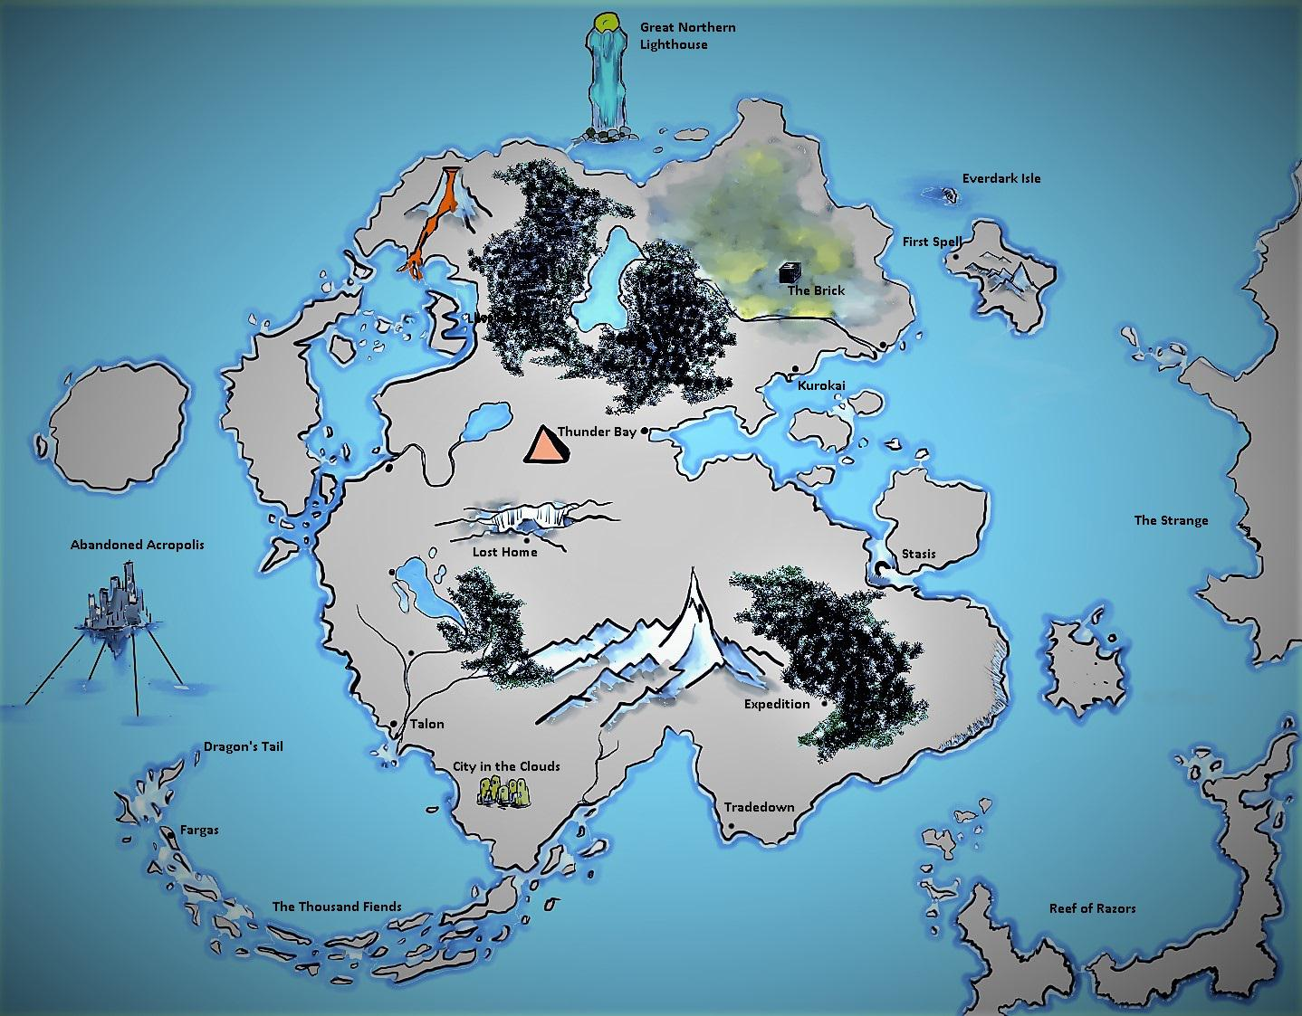
Γ Ν Δ

